

PROJECT TITLE

Sewer Safety System: A Lifeline for Sewage Pit Cleaners

# Engineering Clinics

*Final Review*

ECS Id :240308

# Guided By

Prof.Y Mohamed Sirajudeen

# Team Members

Harshini G - 22BCE9386

Vammsi Krishna P - 21BCE7667

Navya Sri Ch - 22BCE8055

Abi Karimireddy - 22BCE7140

Hashmitha Anjana K - 21BCE7042

Goharunnisaa Md - 22BCE8838

**ABSTRACT:**

The Sewer Safety System (SSS) represents a critical advancement in urban infrastructure management, addressing the inherent risks associated with toxic gas accumulation in sewer networks. By deploying Arduino-based gas sensors strategically throughout the sewer system, the SSS enables continuous monitoring of gas levels, including hydrogen sulfide (H2S) and methane (CH4), which are common hazards in such environments. Real-time gas concentration values are displayed on an LCD display unit, providing sewer workers with immediate visual feedback to assess environmental conditions.

Furthermore, the SSS incorporates a DF Mini MP3 player connected to a speaker, facilitating the delivery of dynamic voice instructions and alerts based on the detected gas levels. This proactive approach ensures that sewer workers receive timely guidance, including directives to wait before entering potentially hazardous areas, with the duration of the wait time adjusted dynamically according to the severity of gas concentration levels.

The integration of advanced technology within the SSS not only enhances safety protocols but also minimizes the risk of gas-related accidents in sewer maintenance operations. By providing comprehensive monitoring capabilities and actionable insights, the SSS contributes to the protection of worker well-being and public health, safeguarding communities against the potential dangers of toxic gas exposure in urban sewer environments.

In summary, the Sewer Safety System represents a significant step forward in urban infrastructure safety, combining innovative sensing technology with real-time monitoring and communication capabilities to create a safer working environment for sewer maintenance personnel and ensure the continued reliability and functionality of essential sewer networks.

**INDEX:**

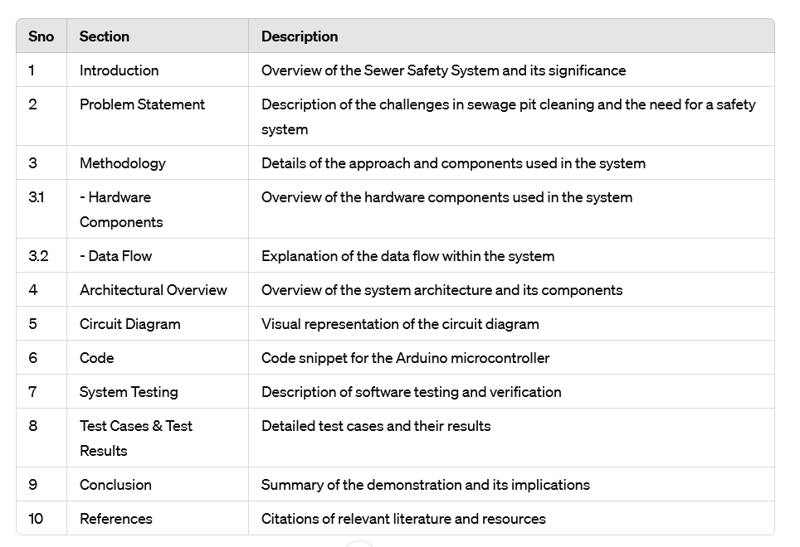

**INTRODUCTION:**

The hazardous environment of sewage pits demands innovative solutions to ensure worker safety. The "Sewer Safety System using Arduino" tackles this challenge with a robust and cost-effective approach. This system utilizes an Arduino microcontroller equipped with a gaseous sensor, continuously monitoring for the presence of harmful gas mixtures beyond just oxygen levels. The system boasts real-time data analysis, automatic alarm triggering with actionable voice alerts, and a design built to withstand harsh conditions. By empowering informed decision-making, enabling proactive hazard detection, and aiming for improved working conditions, this project significantly contributes to the well-being of sewage pit cleaners. Future enhancements like integrating additional gas sensors, machine learning for prediction, and a mobile application for real-time updates solidify this system's potential to revolutionize safety standards in this high-risk field.

**PROBLEM STATEMENT :**

Sewage pit cleaning is a critical yet highly dangerous occupation. Workers are exposed to a multitude of hazardous gases like methane, hydrogen sulfide, and ammonia, which can cause suffocation, respiratory illnesses, and even death. Traditional methods of assessing safety rely on manual testing or worker experience, which are unreliable and leave workers vulnerable. This exposes sewage pit cleaners to unnecessary risks and highlights the urgent need for a more robust and automated safety system.

**METHODOLOGY :**

To effectively demonstrate the Sewer Safety System prototype, we'll follow a controlled environment approach. The key components involved are an Arduino microcontroller, a gas sensor (like the MQ-7), an LCD display, a DF Mini MP3 player, a speaker, and a power source The setup involves connecting the gas sensor to the Arduino as per its instructions, followed by connecting the LCD display and MP3 player using the provided wiring diagram. Once all components have proper power, the demonstration commences. Firstly, we'll simulate gas detection by introducing a small amount of safe gas near the sensor. This will showcase the Arduino receiving sensor data and potentially triggering pre-programmed actions based on set thresholds. Next, the Arduino's control will be demonstrated. By simulating gas levels exceeding pre-defined thresholds within the Arduino code, we can observe how it processes sensor data, triggers safety actions, and sends instructions to the display and MP3 player. The LCD display plays a crucial role in providing real-time feedback.

We'll showcase dynamic updates on the display as simulated gas levels change, keeping workers informed about the environment. Voice instructions are another key feature. Here, exceeding simulated gas thresholds will trigger the DF Mini MP3 player. Pre-recorded voice instructions advising workers to wait for ventilation, with the wait time adjusted based on the simulated gas severity, will be played through the speaker. Finally, the speaker output will be assessed. We'll ensure clear and audible voice instructions from the speaker, prompting workers to take appropriate safety measures based on the communicated information.

This demonstration essentially simulates a complete system operation. The Arduino continuously monitors gas levels through the sensor. When thresholds are exceeded, the Arduino triggers visual alerts on the LCD and plays clear voice instructions through the MP3 player, all while the LCD display provides real-time gas concentration feedback for informed worker decisions. By successfully showcasing these functionalities in a controlled environment, we pave the way for further development and real-world testing of the Sewer Safety System.

**ARCHITECTURAL OVERVIEW:**

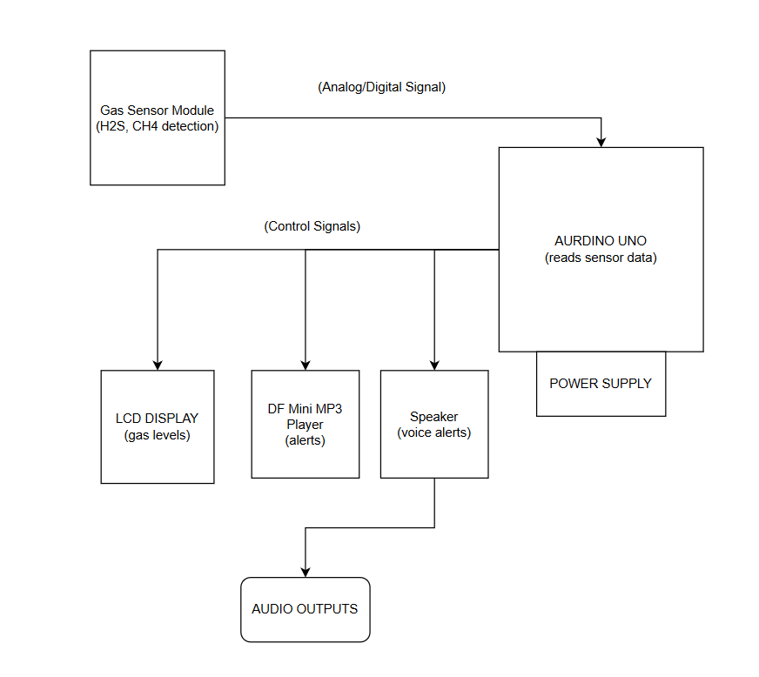

**HARDWARE COMPONENTS:**

**Arduino Microcontroller:**

It acts as the central processing unit, responsible for data acquisition, analysis, and control.

The Arduino microcontroller serves as the brain of the Sewer Safety System. This programmable single-board computer acts like a conductor in an orchestra. It receives data from the gas sensor, analyses it based on pre-set safety thresholds, and triggers actions like displaying alerts or playing voice instructions. The Arduino coordinates all components, ensuring a unified response to potential hazards in the sewer environment.

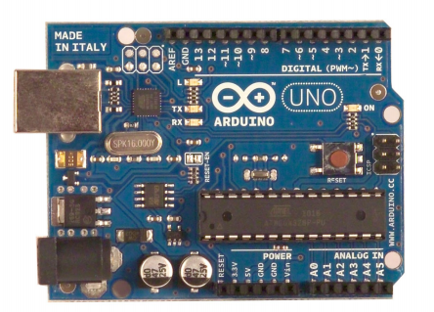

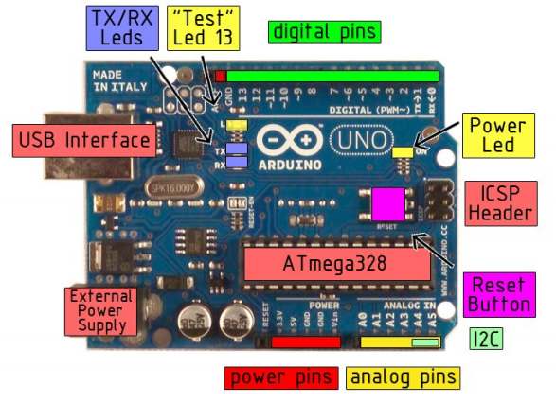

**Gas Sensor (mq-7):**

Detects various hazardous gases present in the sewage pit environment. The gas sensor as a highly-trained bloodhound, sniffing out danger. This sensor, often an MQ-7, is particularly sensitive to harmful gases like methane and carbon monoxide present in sewers. It sends an analog signal to the Arduino, indicating the level of gas concentration it detects. This real-time data is crucial for identifying potential threats and triggering appropriate safety protocols to protect workers from gas exposure

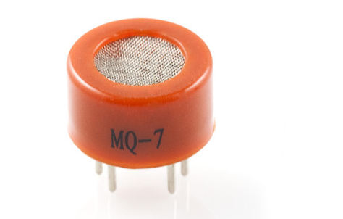

**LCD Display:**

The 16x2 LCD display acts like a watchful eye, keeping workers informed of the environmental conditions. Similar to a car dashboard, it displays two key pieces of information:

1. Real-time gas concentration levels in a clear format, allowing workers to instantly assess the severity of the situation.
2. Pre-programmed messages or alerts triggered by the Arduino, providing additional guidance based on detected gas levels, ensuring workers can take appropriate precautions.

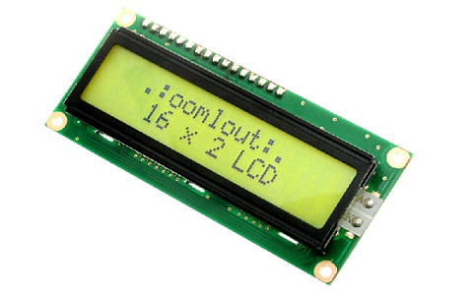

**DF Mini MP3 Player:**

The DF Mini MP3 Player serves as the voice of caution within the Sewer Safety System. Think of it as a pre-recorded safety briefing delivered at the right moment. This compact player stores pre-recorded voice instructions and warnings that are played through a connected speaker. For instance, upon exceeding gas concentration thresholds, the DF Mini MP3 player can instruct workers to wait for ventilation before entering the sewer environment. This ensures workers receive critical safety information and prioritize their well-being.

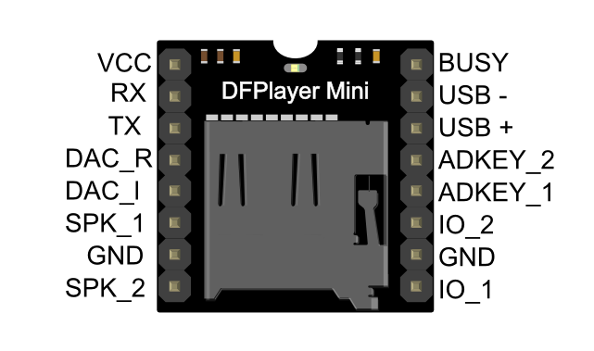

**Speaker:**

The speaker acts as the amplifier of safety, ensuring clear and audible communication of critical messages. Imagine it as a powerful loudspeaker at a concert. Connected to the DF Mini MP3 player, the speaker amplifies pre-recorded instructions and alerts, making them easily heard even in potentially noisy sewer environments. By providing immediate and clear audio cues, the speaker empowers workers to react promptly and take necessary precautions based on the communicated message, ultimately contributing to a safer work environment.



**Power Source:**

Supplies electricity to the entire system.

**Data Flow:**

1. **Gas Detection**:
   * The Gas Sensor continuously measures gas concentrations in the sewage pit environment.
   * The Sensor Block sends the gas concentration data to the Processing Block.
2. **Processing**:
   * The Processing Block receives the data and compares it with pre-defined safety thresholds for different gases.
   * If the gas concentration is below the safety threshold:
     + The Processing Block sends a signal to the Display Block to show "Safe".
     + The Processing Block notifies the Alert Block to remain silent (no messages played).
   * If the gas concentration exceeds the safety threshold:
     + The Processing Block determines the severity level based on multiple thresholds.
     + The Processing Block sends a signal to the Display Block to show the gas concentration level and an "Unsafe" message with wait time based on the severity level.
     + The Processing Block sends a signal to the Alert Block to play a pre-recorded voice message instructing workers to wait for ventilation for a specific duration based on the severity level.

**Pre-programmed Thresholds:**

Arduino is programmed with predefined gas concentration thresholds for different gases.

Conditional Execution: Arduino executes specific actions (e.g., triggering visual and audible alerts) based on the measured gas concentrations exceeding these thresholds.

Adaptive Responses: The system may adjust the severity of safety instructions based on the detected gas levels to ensure appropriate worker response.

This architectural framework demonstrates how the Sewer Safety System using Arduino effectively detects, analyzes, and responds to hazardous conditions in sewage pits, ultimately enhancing worker safety.

**CIRCUIT DIAGRAM:**

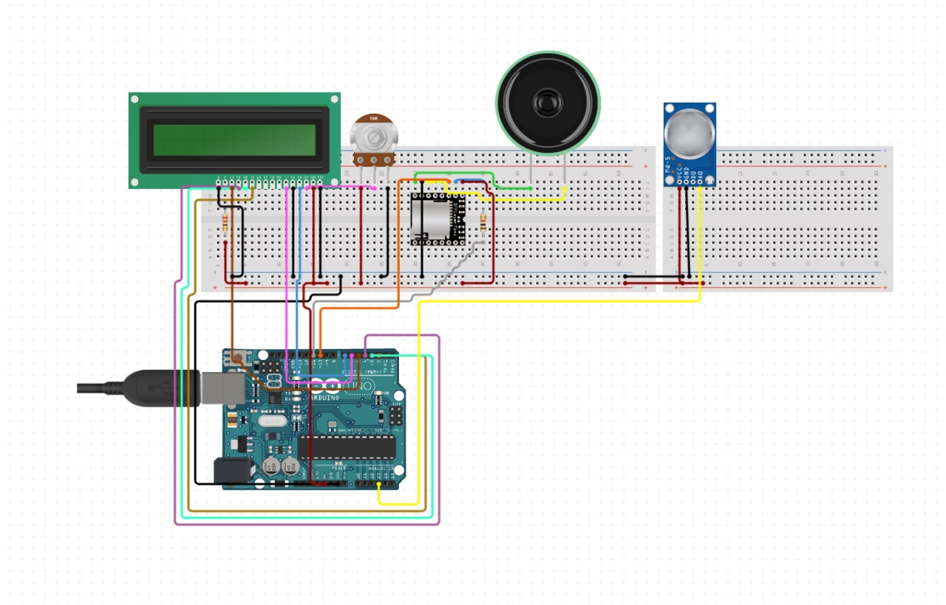

**SEWER SAFETY SYSTEM**

**CODE:**

#include <LiquidCrystal.h>

#include "DFRobotDFPlayerMini.h"

#include<SoftwareSerial.h>

const int rs = 8, en = 9, d4 = 10, d5 = 11, d6 = 12, d7 = 13;

LiquidCrystal lcd(rs, en, d4, d5, d6, d7);

DFRobotDFPlayerMini player;

SoftwareSerial mySerial(2,3);

int ir=7;

int sts=0;

void setup() {

// set up the LCD's number of columns and rows:

lcd.begin(16, 2);

// Print a message to the LCD.

lcd.print("WELCOME");

pinMode(ir,INPUT);

mySerial.begin(9600);

delay(1000);

player.begin(mySerial);

delay(200);

player.volume(30);

player.playMp3Folder(1);

}

void loop() {

int gval=analogRead(A0)/10.23;

lcd.clear();

lcd.print("GAS:"+String(gval) + " Ppm");

if(gval<20)

{

lcd.setCursor(0,1);

lcd.print("Safe ");

sts=0;

}

else if(gval<30)

{

lcd.setCursor(0,1);

lcd.print("UnSafe -5min ");

sts=1;

}

else if(gval<40)

{

lcd.setCursor(0,1);

lcd.print("UnSafe -10min ");

sts=2;

}

else if(gval<50)

{

lcd.setCursor(0,1);

lcd.print("UnSafe -15min ");

sts=3;

}

else if(gval<60)

{

lcd.setCursor(0,1);

lcd.print("UnSafe -20min ");

sts=4;

}

else if(gval<70)

{

lcd.setCursor(0,1);

lcd.print("UnSafe -25min ");

sts=5;

}

else if(gval<80)

{

lcd.setCursor(0,1);

lcd.print("UnSafe -30min ");

sts=6;

}

else

{

lcd.setCursor(0,1);

lcd.print("Danger -*");

sts=7;

}

delay(5000);

if(digitalRead(ir)==0)

{

if(sts==0)

{

player.playMp3Folder(1);

delay(500);

}

if(sts==1)

{

player.playMp3Folder(2);

delay(500);

}

if(sts==2)

{

player.playMp3Folder(3);

delay(500);

}

if(sts==3)

{

player.playMp3Folder(4);

delay(500);

}

if(sts==4)

{

player.playMp3Folder(5);

delay(500);

}

if(sts==5)

{

player.playMp3Folder(6);

delay(500);

}

if(sts==6)

{

player.playMp3Folder(7);

delay(500);

}

if(sts==7)

{

player.playMp3Folder(8);

delay(500);

  }

  }

}

**SYSTEM TESTING:**

Software testing is defined as an activity to check whether the actual results match the expected results and to ensure that the software system is Defect free. It involves execution of a software component or system component to evaluate one or more properties of interest. It can be either done manually or using automated tools.

**TEST CASES & TEST RESULTS:**

These test cases cover various scenarios to ensure that the system functions correctly under different conditions and that the LCD display and voice alerts are synchronized appropriately with the gas concentration levels**.**

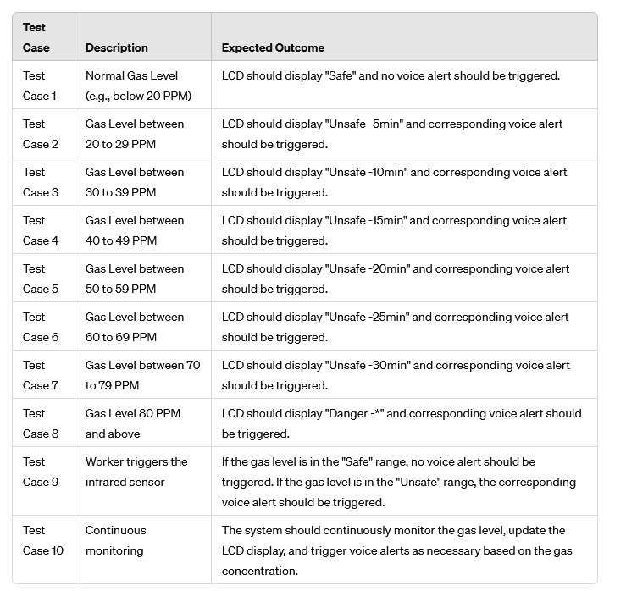

**CONCLUSION:**

In conclusion, this controlled environment demonstration effectively validates the core functionalities of the Sewer Safety System prototype. By simulating gas detection, Arduino control, real-time LCD feedback, clear voice instructions, and proper speaker output, we've established a strong foundation for further development. This successful demonstration paves the way for real-world testing, where the system can be evaluated in actual sewer environments. Here, data collected will allow for further refinement of gas detection thresholds, voice instruction content, and system response times. Additionally, real-world testing will expose the system to a wider range of environmental factors, allowing for optimization of its performance and durability.

**REFERENCES:**

1. "Development of a methane concentration monitoring system for sewer safety" by Journal of Loss Prevention in the Process Industries (2018): This paper explores a methane monitoring system for sewer safety using a microcontroller and wireless communication. It delves into sensor selection, data transmission, and alarm generation, potentially offering valuable insights for your Arduino-based project.
2. "A Review of Sewer Safety Technologies" by Automation in Construction (2016): This journal article provides a broader perspective on sewer safety technologies. While it might not focus solely on Arduino-based systems, it can expose you to various approaches for hazard detection, ventilation techniques, and worker protection strategies, enriching your understanding of the overall challenge.
3. "Sensor Technologies for Wastewater Characterization" by Sensors (2018): This research paper explores sensor technologies used for wastewater characterization. While not directly related to sewer safety systems, it can provide valuable information on various gas sensors and their functionalities. This knowledge can be helpful when selecting and integrating a gas sensor with your Arduino for optimal detection of harmful gases in sewage pits.